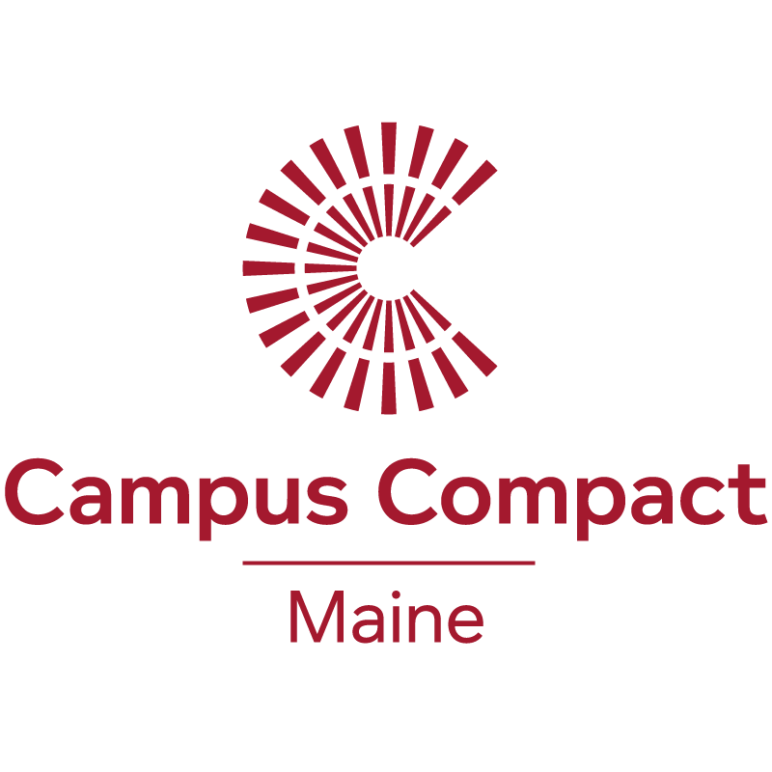

Student Fellowship Application

Food Waste and Recovery and/or Campus Kitchens Project

In 2017 the Maine Hunger Dialogue planning team is offering three $1000 student fellowships for students serious about combating food waste and turning “recovered food” into nutritious meals for those who are struggling with food insecurity. In the process, we wish to support development of student leaders and empower them in creating programs and pathways between college and community for student powered hunger relief.

Note: While the Maine Hunger Dialogue is partnering with the Campus Kitchens Program (www.campuskitchens.org) with our 2017 theme of “Food Waste and Recovery”, selected fellows are not obligated to start a chapter of Campus Kitchens Program, but rather to explore and form an implementation plan for a food waste and recovery effort at your college or university. Of course, if you do wish to work towards establishing a Campus Kitchens Project that would be most welcomed. In either case, we will utilize Campus Kitchens excellent resources in establishing these fellowships. Also, Campus Kitchens Project will be offering $5000 implementation grants this coming spring and fellows would be in an ideal position to apply.

The Campus Kitchens Program outlines four key components necessary to create a successful food waste and recovery program including:

- Food recovery: Campus volunteers pick up unused, quality food from campus dining providers, as well as from local grocery stores, food banks, farms and farmers’ markets. Trained volunteers cook and store the donations according to established food handling regulations. The federal Good Samaritan Food Donation Act protects schools and food donors who participate in food recovery programs.

- Meal preparation: Using donated kitchen space during off hours, volunteers utilize the food donations to prepare balanced and nourishing meals. Often, Campus Kitchens are able to prepare meal boxes or backpacks with shelf stable items which allows clients to create meals on days when there is no delivery scheduled.

- Meal delivery: Volunteers deliver prepared meals to organizations as well as to low-income families and individuals. Often, volunteers stay to share conversations, education and sometimes a meal with recipients. This exchange provides valuable interaction for our recipients and greater understanding of poverty for students.

- Empowerment and education: Each Campus Kitchen engages in empowering education programs like culinary job training for unemployed or underemployed adults, healthy cooking classes for families and nutrition education for kids. Most Campus Kitchens are empowering their communities through the development of gardens and the use of the fresh produce grown. Some kitchens have even created their own farmers’ market, which accept SNAP (formerly food stamps) to provide the community with access to farm fresh products.
As a fellow, you will be in charge of planning for either a Food Waste and Recovery Program and/or Campus Kitchen at your school. You will work alongside fellows from other universities and colleges in Maine and beyond also planning for Campus Kitchens giving you a system of support throughout the planning process. Successful Fellowship Applicants will research and report on the 4 Pillars of Planning Establishing a Food Waste and Recovery Program and/or Campus Kitchens Project on their campus including:

- Student Support
Pitch the idea for a Food Waste and Recovery effort to fellow students on campus. Form a team of 5-12 students that will be the students that plan and organize for a Campus Food Waste and Recovery Program.

2) Dining Support
You will work with dining managers to develop a feasible food recovery and food preparation plan that works for everyone (developing a detailed feasibility plan). Include the feasibility of recovering leftover, unused food from dining. Then using dining kitchen space during quite off hours to prepare nutritious meals. You will reach out to dining managers and pitch the idea for a Food Waste and Recovery Program to dining as well as discussing food recovery as well as meal preparation space.

3) School Support
Each Campus Kitchen needs a Sponsoring Office on-campus. This sponsoring office will endorse the Campus Kitchen as an official organization at the school. This ensures that the Campus Kitchen will not go away even after the founders graduate. The Sponsoring Office will also likely, factor the affiliate fee into their annual budget. So, you will reach out to an office on campus that you think will sponsor the Campus Kitchen (ideas: sustainability, civic engagement, community service, Dean of Academics/Students, etc)... and you will work with them to fill out a feasibility plan so that you have their full support for the long term.

4) Community Support
In order to successfully deliver meals to a community partner, you need a community partner! You will research local organizations in your community and reach out to them to see if they are interested in receiving healthy meals from the Campus Kitchen at your school. Remember, you also offer friendships for residents (if it’s low-income housing, elderly housing, homeless shelter, etc.) Through meal delivery, community dinners, and other fun programming that the organization/residents want, you will build a community between the university and the surrounding community.

Please utilize the Campus Kitchens Project Online Toolkit located via their web site http://www.campuskitchens.org/what-is-the-planner in developing your application. You will have to fill out a short online form to gain access to the Toolkit.

Make your application unique to your campus.

Fellowship Application

Campus Kitchens Project and/or Food Waste and Recovery Program

To apply, please answer the following questions and return your fellowship application no later than Monday, January 31st via email to katie@mainecompact.org. Applications should not exceed four pages. For more information, please contact Katie Kracht, Maine Hunger Dialogue VISTA at katie@mainecompact.org or Tel: 207.786.8386

- Name of Fellowship Applicant:

- Name of College/University

- Contact information for the Fellowship Applicant:
Address:
Phone:
Email:

- In 500 words or less, describe your motivation and interest in initiating a Campus Kitchens Project or Food Waste and Recovery program at your college or university campus:

- In preparing this fellowship application have you had any preliminary discussions related to the four pillars of planning for a food waste and recovery program (Student Support, Dining Support, School Support, Community Support)?

If so, please describe:

- Please describe any previous experiences you have had related to student leadership, community volunteering, program or project development or other related experiences:

- (Optional) Other thoughts, goals or desires you wish to share:

