Name__________________________

When and where did signs of Monarchs and Milkweeds first appear in Maine in 2011?

Volunteers around Maine have been recording dates for different stages of Monarch butterflies and Milkweed plants. Below are the earliest sightings by observers in a number of different towns in 2011.
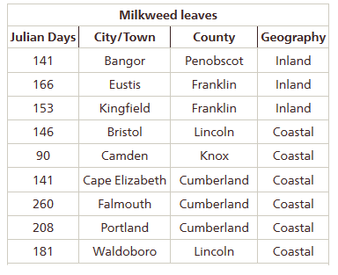
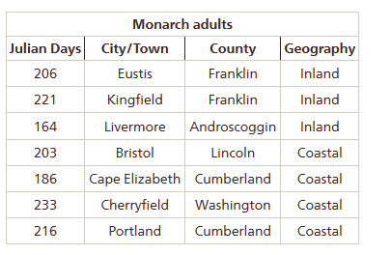
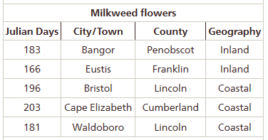
Predict:
Monarchbutterfly.org
1. Which would you expect to see first: adult monarchs, milkweed leaves or milkweed flowers? Why?

2. Where would you expect to find monarchs first: in coastal Maine or inland Maine? Why?

3. What type of graph(s) would you use to answer the questions above? Plan and graph the data.

Analyze:
4. List the following in order of their arrival based on your graphs: adult monarchs, milkweed leaves, milkweed flowers

5. About how many days apart do the above arrive?

6. Which occurs first: coastal or inland monarch sightings?

7. How many days, on average, are there between the first coastal and the first inland sightings?

8. Create appropriate graphs to answer the following questions: How variable is the timing of the first monarch sighting? How variable is the appearance of milkweed?

Discuss:
9. What environmental factors might influence the arrival of monarchs or the appearnce of milkweed?

10. Climate change predictions for the northeast suggest that temperatures in Maine will increase over the next hundred years. How would you expect the timing of milkweed and monarch appearance to change as Maine warms?

11. What could be done to make this dataset more reliable?

