Sample

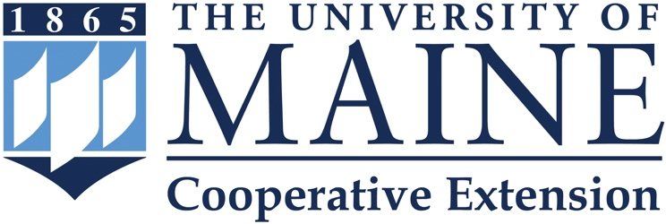

University of Maine Cooperative Extension Internship Evaluation Form

The intern would fill out this form upon completion of the Cooperative Extension internship experience if they are completing the internship for credit.

Intern Information

Name_______________________________ Email__________________________________

Address____________________________________________________________________

Phone______________________________ Date of Internship Completion______________

Mentor/Supervisor Information

Name_______________________________ Email__________________________________

Address____________________________________________________________________

Phone______________________________ Date of Internship Completion______________

What campus and/or campus activities helped prepare you for the Extension internship experience?

How did your internship orientation experience prepare you for your internship with Cooperative Extension?

What were the most helpful things that your mentor/supervisor did to help you adjust to being an Extension intern?

How did the internship experience support your future career goals?

How did your Cooperative Extension internship experience impact you?
Think about the questions below as you respond to this question.
Did your work…
* Increase your skills and knowledge?
* Change or expand your career goals?
* Provide an opportunity to apply your academic learning to real life experiences?
* Create new attitudes and understanding about my future career objectives?

What was the educational value of your Extension internship experience?

How did the internship experience relate to your academic major and career goals?

Please reflect on your mentor/supervisor’s willingness and ability to support your questions and work as an Extension intern, as well as their receptiveness to ideas.

What changes (if any) would you make to the Cooperative Extension Internship Program?

What did you learn from the research component of your Cooperative Extension Internship? Please include any new skills you may have learned from the research experience.

