
Contact: Frank Wertheim
University of Maine Cooperative Extension
York County Office
21 Bradeen Street, Suite 302
Springvale, ME 04083
Tel. 324-2814 or 1-800-287-1535
Frank.wertheim@maine.edu

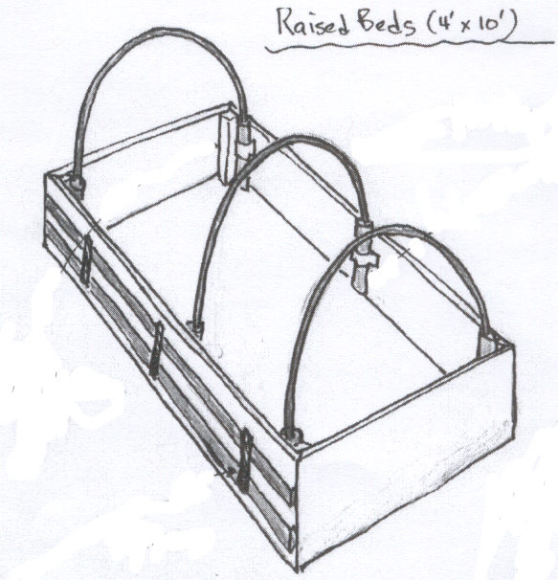
Raised Beds for Season Extension

To view a Video Clip and Download Plans on how to build your own Season Extension Raised Bed Visit:

http://umaine.edu/gardening/resources/extending-the-gardening-season-using-raised-beds-parts-1-4/

Or Google:

UMaine Extension Video Extending the Garden Season Using Raised Beds
A Member of the University of Maine System

Published and distributed in furtherance of Acts of Congress of May 8 and June 30, 1914, by the University of Maine Cooperative Extension, the Land Grant University of the state of Maine and the U.S. Department of Agriculture cooperating. Cooperative Extension and other agencies of the U.S.D.A. provide equal opportunities in programs and employment.

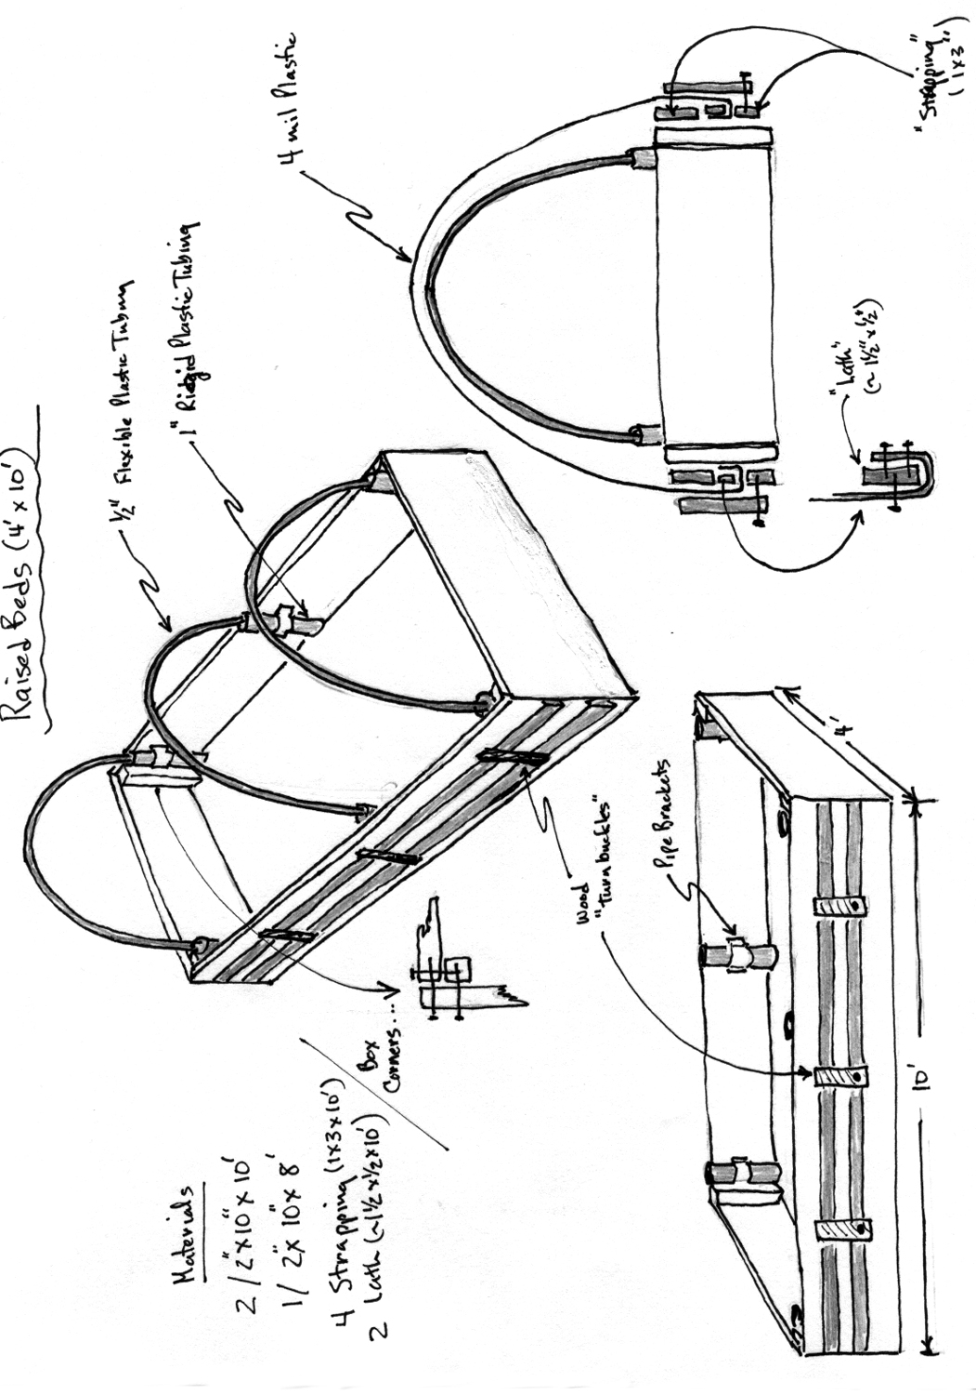
Materials List for One 4’ x 8’ Raised Bed

- 24 board feet of 2” x 10” rough cut planking – 2 pieces 4’long, 2 pieces 8’ long
- 1 piece of rigid 1 ¼ PVC pipe, comes in 10’ length – for holding hoop – cut 6 pieces to 10” lengths
- 12 or one packet of 1 ¼ inch pipe brackets, for attaching 10” rigid PVC pieces to planking
- 3 Flexible PVC pipes, ½” x 10’ long – cut with hacksaw to 9’ length – provides hoops
- 4 pieces of 8’ long, 1” x 3” strapping – for creating channels for holding poly
- Polyethylene plastic sheet 4 ml, 10’ wide x 15’ long
- 2 pieces of 8’ lath – for holding plastic in channel
- 4-8 hardware clamps
- 6 pieces of 6” long 1”x 3” strapping scraps – for turnbuckles
- sheet rock screws- for holding turnbuckles on bottom piece of strapping

Optional – for vertical growing
- 3 electrical conduit pipes, 10 foot length x 5/8” – for holding trellis
- 8’ length strapping for trellis crossbar
- 4” x 4” netting – piece 8’ long x 6’ high – staple to strapping and bolt strapping to pipe.

