2020 York County Master Gardener Review 2
Due Back via email or snail mail by June 4th – if you need more time due to Covid-19 let us know.

This review is open book take home and you may discuss the questions with your fellow Master Gardeners.

Note: Please print NEATLY or use a word version from the blog and do it on your computer.

Name:_____________________________________

Home Garden Plant Disease

- What is an example of an abiotic plant disease?

- Choose 1. The majority of biotic plant disease are caused by (Fungal/Bacterial/Viral) pathogens?

- What are the three components of the disease triangle, and how would you use this knowledge to combat plant disease in the home garden?

Insects in the Home Garden

- The three distinct body regions of an insect are called:

- Aphids have: a) chewing b) sucking c) sponging mouthparts.

- Beetles have: a) chewing b) sucking c) sponging mouthparts.

- Butterflies undergo ___________ metamorphosis.

- Squash bugs undergo ___________ metamorphosis.

Weed Management

- When cultivating the soil for weed management, why is it recommended to cultivate shallow just below the soil surface?

- From question 9, at what plant stage (developmental stage) does shallow cultivation work the best?

At what plant stage is it less effective?

- How does knowing whether a particular weed is an annual or a perennial help in developing a control strategy?

Drip Irrigation and Rain Barrels:

- Why does drip irrigation allow water to penetrate the soil more deeply than in using an overhead sprinkler system? Hint: refer to the fact sheet on drip irrigation from the blog post.

- A rain barrel must be elevated by ______ feet above the garden surface to gain 1 Pound per Square Inch (PSI) of pressure. Hint: refer to the fact sheet on drip irrigation from the blog post.

- I have an 1800 sq. ft. roof. It rains 1 inch. How much water has run off this roof?
(Hint refer to fact sheet from blog on Rain Harvesting)

Raised Beds

- List 3 advantages and 3 disadvantages for gardening in raised beds.

Advantages:

Disadvantages:

- Why is it recommended that raised beds be no wider than 4 feet?

- Raised beds have limited space, therefore, what are some strategies (list 3) you could adopt for to plan for a continuous harvest and keep the bed full all season long?

Planting with Natives Maine Plants

- Why are native plants more important for local flora and fauna than plants which, while they are not invasive, did not evolve here?

- List 5 herbaceous plants (common name and Latin names) native to Maine that would both do well in the landscape and also support native pollinators:

- List 4 considerations you would consider for determining what is the “Right Plant for the Right Place”:

- List 5 woody ornamental plants (common name and Latin names) native to Maine that would both do well in the landscape and also support native pollinators:

Plant ID – Use Newcomb’s Wildflower and Forest Trees of Maine

- Specimen # 1 (3 Views of Same Plant)

Common Name:

Latin Name:

1 Interesting fact about this plant:

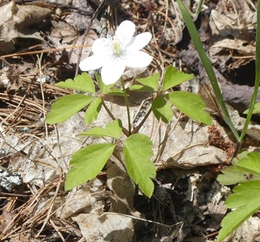
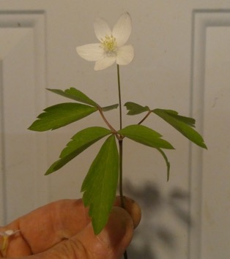
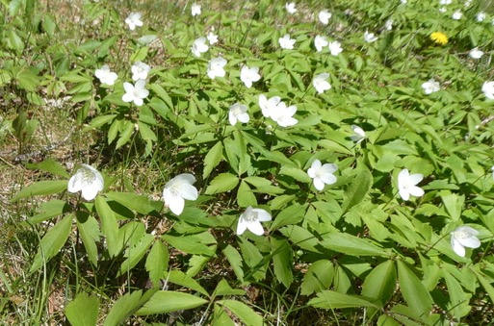

- Specimen # 2 (2 Views of Same Plant)

Common Name:

Latin Name:

1 Interesting fact about this plant:
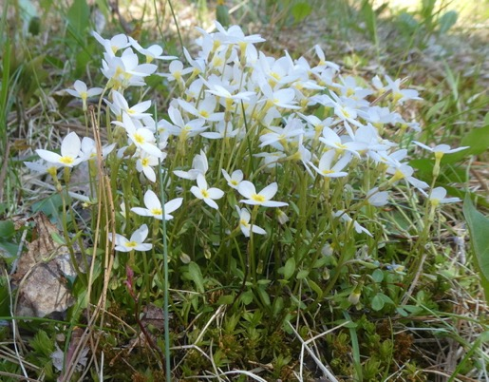
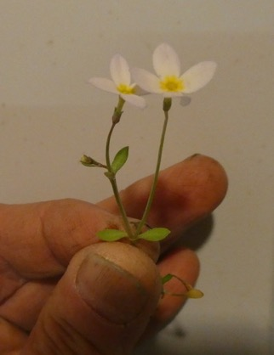

Forest Tree ID

- Specimen # 1 (4 Views of Same Plant)

Common Name:

Latin Name:

1 Interesting fact about this plant:

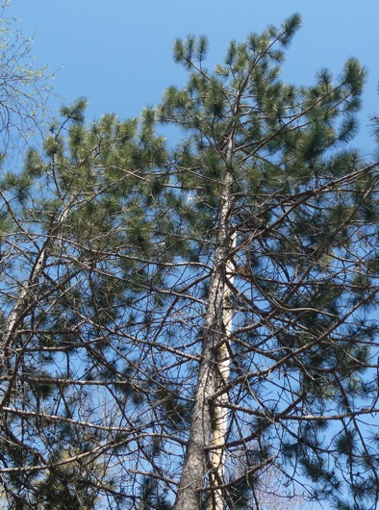

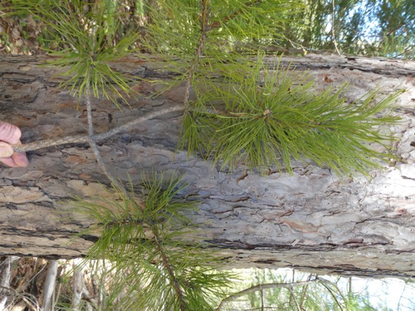

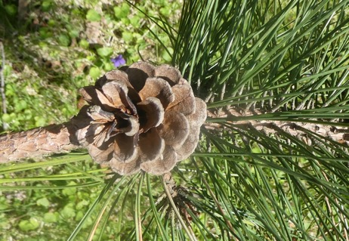
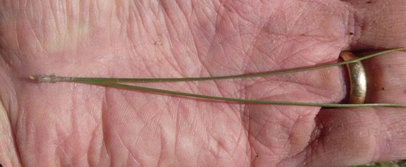

- Specimen # 2 (2 Views of Same Plant)

Common Name:

Latin Name:

1 Interesting fact about this plant:

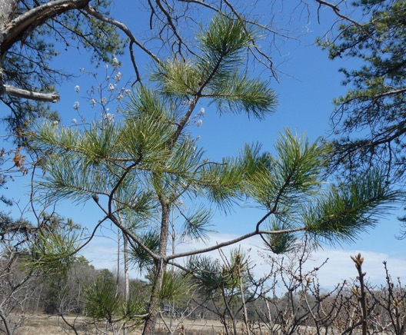
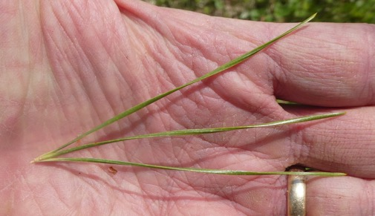

Extra Credit:

Complete this original poem:

Trillium erectum is Red

Delphinium elatum can be Blue

Solanum lycopersicum dance in Frank’s head

Lavandula angustifolia is for Sue

Continue to next page: Course Evaluation
Master Gardener Course Evaluation - 2020

It would be helpful for future Master Gardener courses if you could give us some basic feedback on the training portion of the program.

If you wish your comments to be confidential, please mail this in in a separate envelope without your return address and don’t sign it.

- In general, how would you rate the Master Gardener Training you have just completed?

1 2 3 4 5 6 7 8 9 10
poor excellent

- What did you like best about the training? Please be specific.

- What parts of the training could use improvement? Please be specific

- What session(s) of the training did you most appreciate? Why?

- Please rate the handouts that you received in class.
1 2 3 4 5 6 7 8 9 10
Not useful Very useful

- As a result of Master Gardener training do you plan to alter your use of pesticides (organic or not) and garden fertilizers? YES NO

- Reduced use of pesticides? YES NO

- Use agricultural chemicals with less toxicity? YES NO

- Plan to adopt cultural practices that reduce the use of pesticides? YES NO

- As a result of your Master Gardener training, will your gardening/landscaping practices change and if so how?

- Do you have a greater awareness of how your gardening/landscaping practices affect the local ecology?

- Do you feel adequately prepared for the volunteer internship portion of the program? Please comment:

- As a Master Gardener, is there an experience, success story or comment you would like to share about your experience in the program?

- Other Comments

Thank You!

